32.16: a) The average power from the beam is
b) We have, using Eq. 32.29, 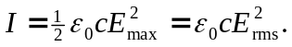 Thus,
